# **Learning Journal - Unit 5**

Computer Science, University of the People

CS 2203-01 Databases 1 - AY2024-T3

Instructor, Irfan Rashid Thoker

March 6, 2024

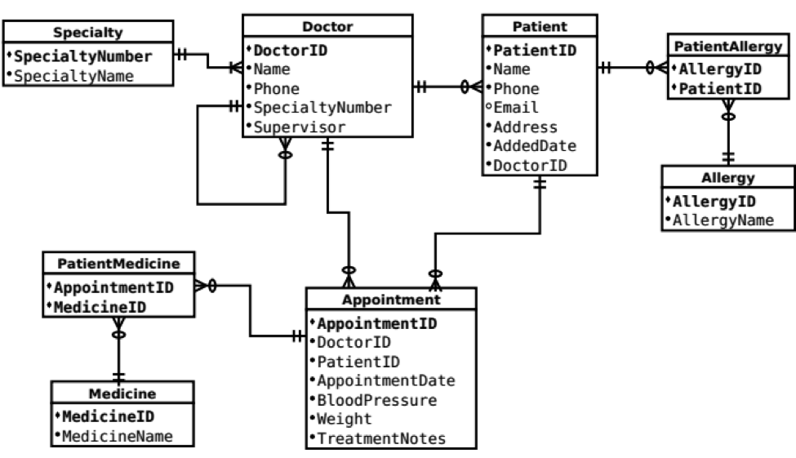This week I was tasked with taking the ERD provided and reading, understanding and describing the relationships between the tables.

Cardinalities and Connections:

* **Doctor** 🡨🡪 **Patient**: in this relationship, we see that a doctor can have multiple patients with the option of having no patients at all. On the other hand, a patient can have one and only one doctor and there is no option for a patient to exist with no attending doctor.
* **Doctor 🡨🡪 Specialty**: a doctor has a single speciality which is mandatory. While each speciality might be shared by multiple doctors, making this a classic one-to-many relationship.
* **Doctor 🡨🡪 Doctor**: this is a recursive relationship allowing each doctor to be related to the doctor who is his direct supervisor. This helps us build a hierarchy tree of management in the hospital. We see that each doctor can have only one direct supervisor while a doctor might have multiple doctors under his supervision.
* **Patient 🡨🡪 Appointment**: patients are allowed to have multiple appointments while each appointment is connected to only one patient. This is a mandatory relationship meaning that there can be no appointments that do not have a patient attached to them.
* **Appointment 🡨🡪 Doctor**: appointments are connected to a single doctor while doctors might have multiple appointments related to them. This too is mandatory since there can not be an appointment with no doctor attached to it. Each record in patient medicine connects to a single appointment to a single medicine where multiple medicines can be connected to a single appointment.
* **PatientMedicine 🡨🡪 Medicine**: This is part of the many-to-many relationship that allows us to connect multiple medicines to multiple patients. The patient medicine is our middleware table that connects the two.
* **PatientAllergy 🡨🡪 Allergy**: on the same thread this is also part of a many-to-many relationship between patients and allergies. This allows us to connect multiple patients to multiple allergies. Each row in patient allergy is connected to a single allergy and each allergy can be connected to multiple patients.

A deeper explanation of the Many-To-Many relationships:

* **PatientMedicine** – this many-to-many relationship was created to help us make connections between multiple patients and multiple medicines. Allowing us to record a patient's need for multiple medicines while each medicine can and most likely will be used by more than one patient. For instance, insulin is a popular medicine that will be used by multiple patients.
* **PatientAllergy** – more of the same as this many-to-many relationship allows us to manage the connection between multiple patients and multiple allergies. This allows us to document the fact that every patient might have multiple allergies such as to different types of nuts while on the other hand nuts being a very popular allergy is going to be connected to multiple patients.

The use of these many-to-many relationships helps us make our database as efficient as possible while removing redundant data. It also makes it easier for us to manage and maintain the different medicines and allergies in a single place.

## References

* Learning Guide Unit 1-5  
  <https://my.uopeople.edu/course/view.php?id=7455>
* Sharma, N., Perniu, L., Chong, R. F., Iyer, A., Nandan, C., Mitea, A. C., Nonvinkere, M. & Danubianu, M. (2010). Database fundamentals. IBM Canada.  
  <https://my.uopeople.edu/pluginfile.php/1827130/mod_book/chapter/484065/Database_Fundamentals.pdf>
* Watt, A., & Eng, N. (2014). Database design,  2nd ed. BCcampus, BC Open Textbook Project.   
  <https://opentextbc.ca/dbdesign01/>  
  <https://my.uopeople.edu/pluginfile.php/1827130/mod_book/chapter/484065/Database-Design-2nd-Edition-1560272109.pdf>